Proof of ownership:
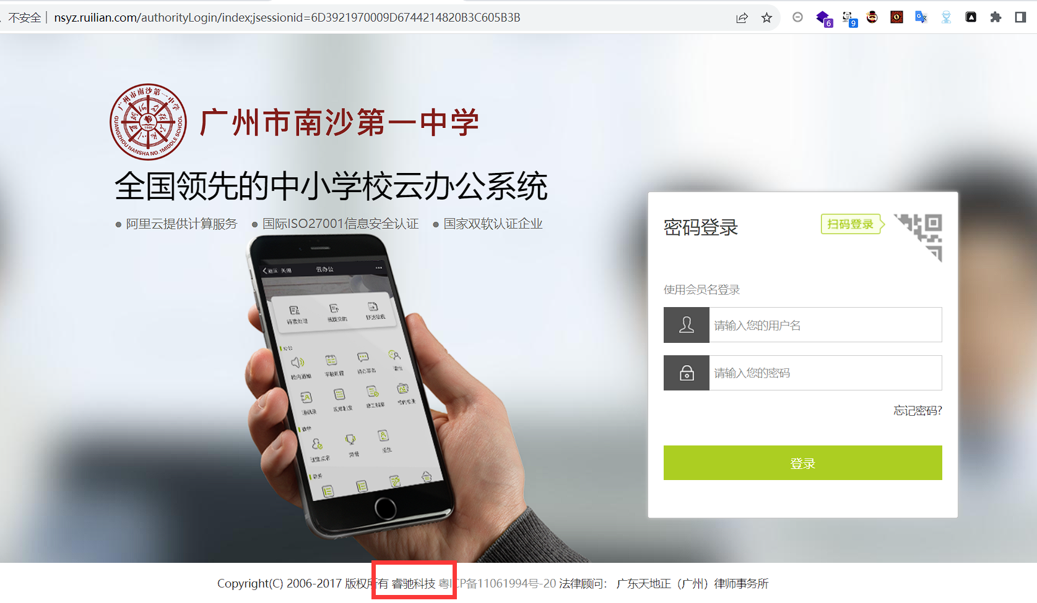
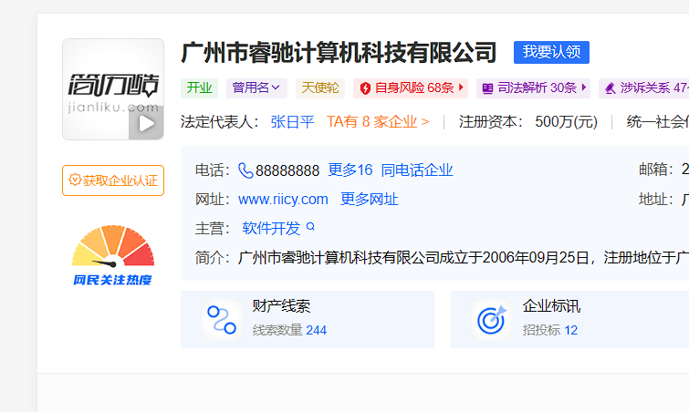

Vulnerability recurrence:
URL：http://nsyz.ruilian.com/
Account number/Password：admin/123456
http://nsyz.ruilian.com/druid/websession.html
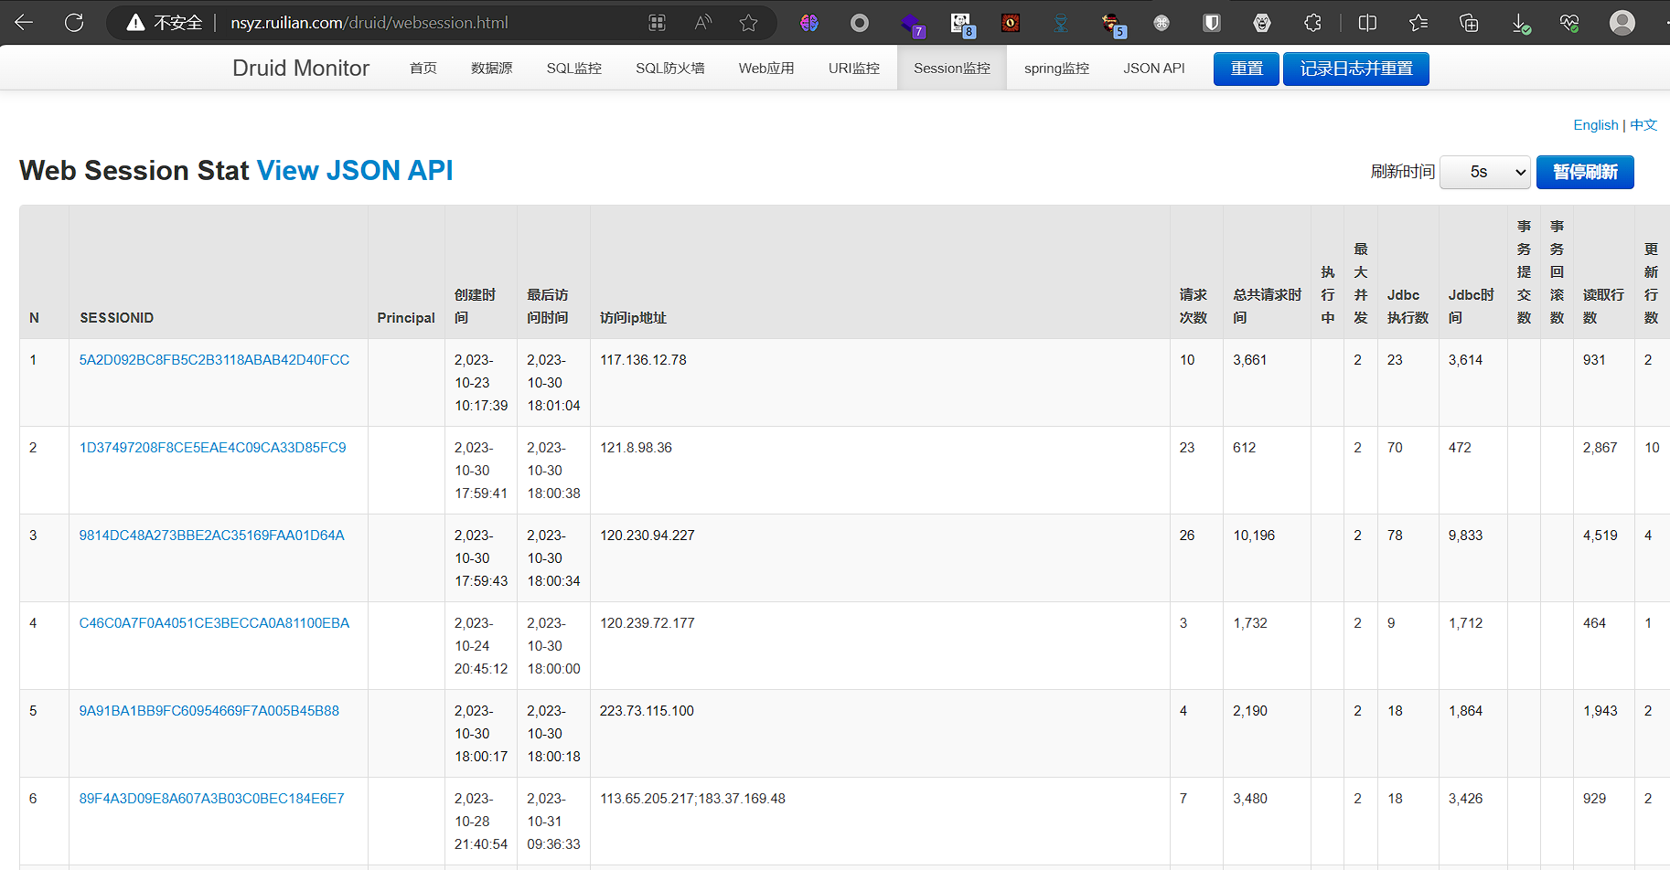

Other examples
They all have the above loopholes

http://gdfx.ruilian.com/
http://newsys.ruilian.com/
http://yucai.ruilian.com/
http://kxc.ruilian.com/
http://zyzx.ruilian.com/
http://nsxx.ruilian.com/
http://bjhf.ruilian.com/
http://meilun.ruilian.com/

